//Fetching all matches and returning them as T_N_O_M_P
MATCH (m:Match)
RETURN COUNT (*) as Total_Number_Of_Matches_Played;
Initially fetches all nodes with label Match and returns the count of them as Total_Number_Of_Matches_Played
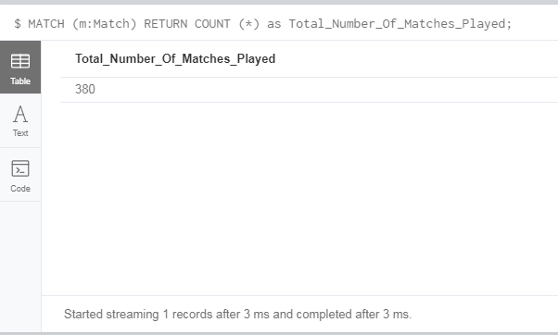
1-Result
//fetches all mathces where title contains Manchester United FC
//and returning all the information
MATCH (n)
WHERE n.title =~ '.*Manchester United FC.*'
RETURN n.title as Teams,n.Date as Date_Of_Match,n.HT as First_half_Score,n.FT as Final_Score,n.Round as Round

Fetching matches where title contains “Manchester United FC” and returns all information of each match.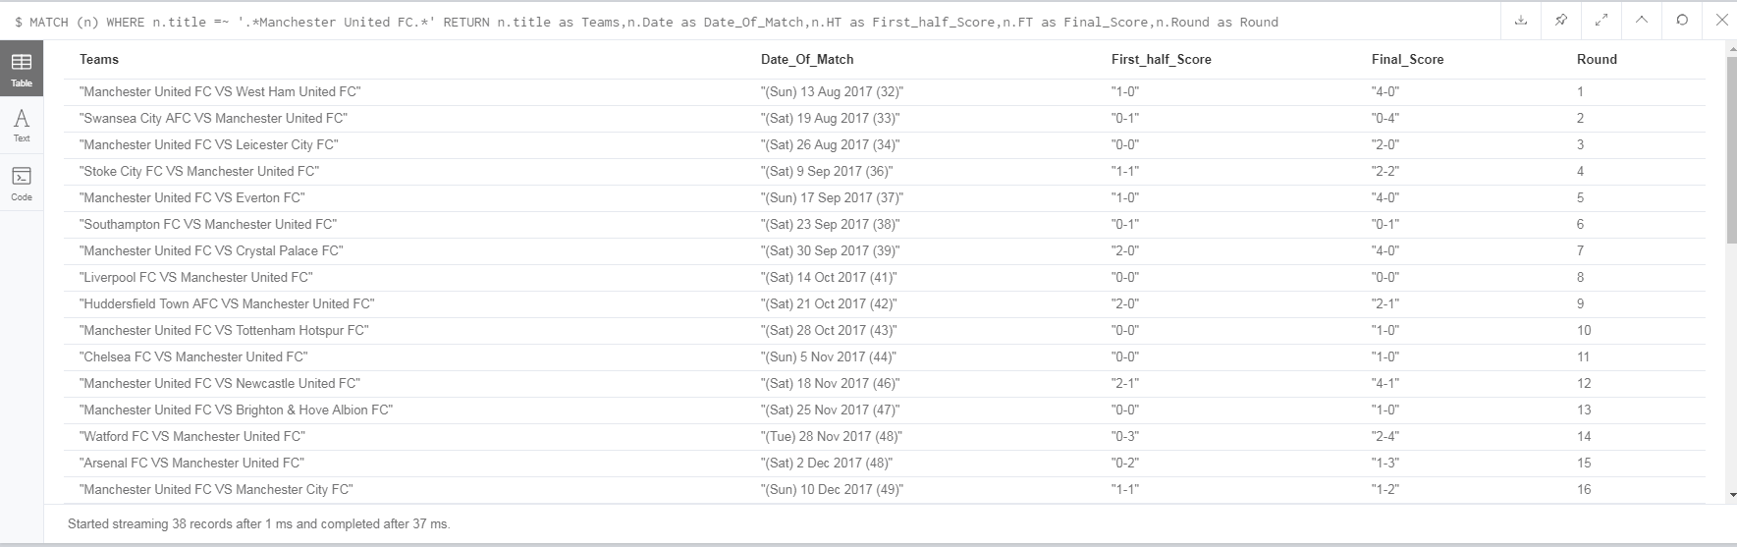
2-Result

MATCH (m:Team)
RETURN m.name as Teams;
Matches all nodes with label Team and returns a list with all team names.
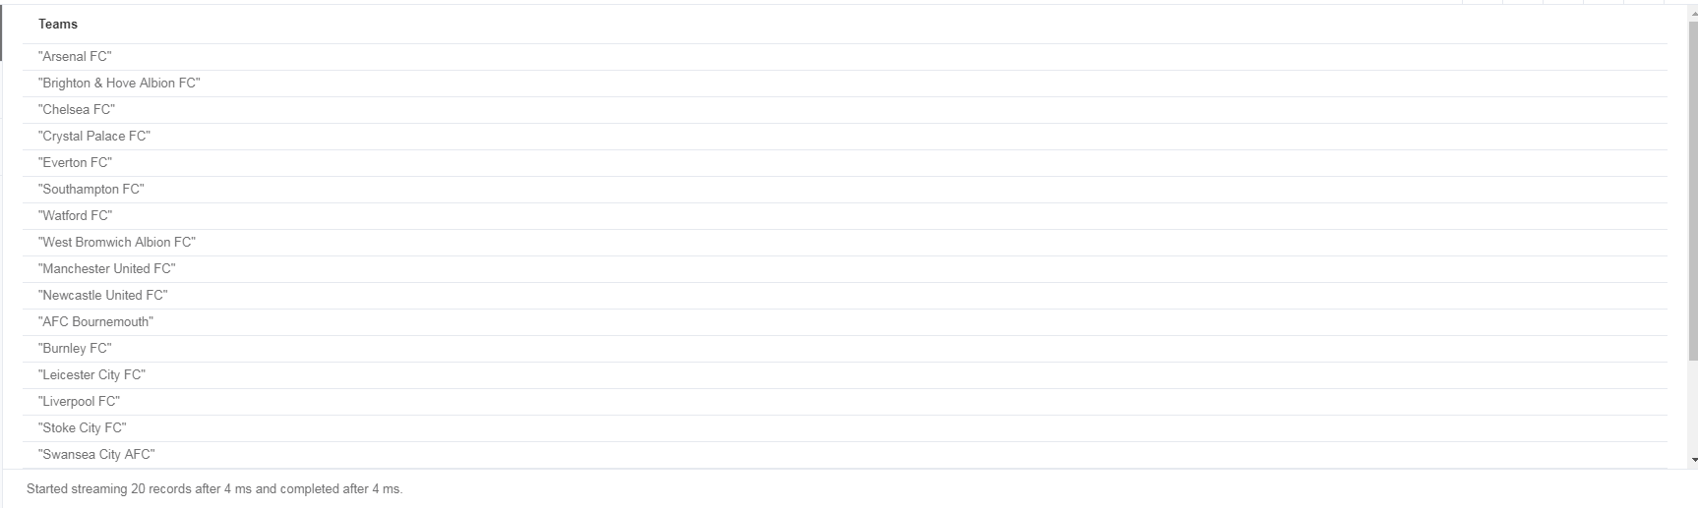
3-Result

//Fetching the relationship and filters where
//the result is won and the date contains jan
MATCH (t:Team)-[x:PLAYED_HOME_IN|PLAYED_AWAY_IN]->(m:Match)
WHERE x.result =~ '.*WON.*' AND m.Date CONTAINS 'Jan'
RETURN t.name as Team_Name, COUNT (x.result) as Winning_Matches_In_January
ORDER BY COUNT (x.result) DESC
limit 1
Initially fetches all teams, relationships and all matches. Then checks where the result of each relationship contains the string WON and the date of each match that contains the string‘Jan’. Returns the name of each team and counts the frequency of WON in JAN.
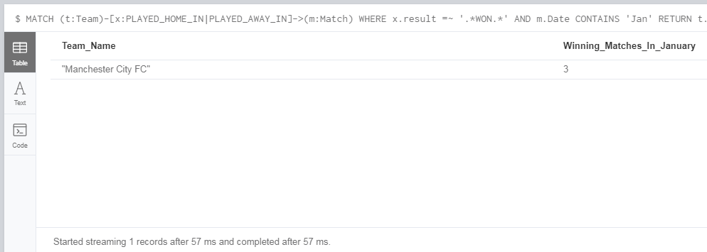
4-Result
Another approach is to return a bigger number of teams because more than one teams has scored 3 goals in JAN.

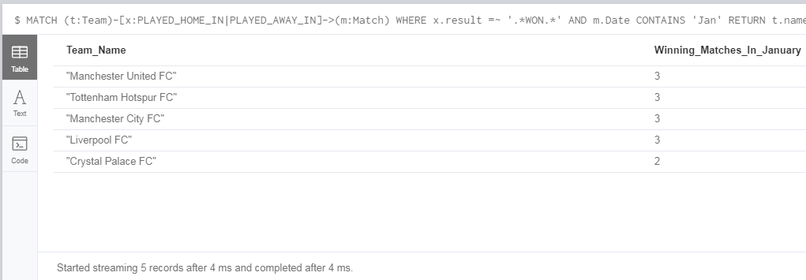
4-Alternative Approach Result

//FETCHING THE RELATIONSHIP AND THE NODES
MATCH (t:Team)-[x:PLAYED_HOME_IN|PLAYED_AWAY_IN]->(m:Match)
// RETURNS THE NAME OF THE TEAM AND THE TOTAL NUMBER OF GOALS THAT EACH TEAM
RETURN t.name as Team_Name, SUM (x.FT) as Total_Number_Of_Goals_For
ORDER BY SUM (x.FT) DESC
LIMIT 5
Initially matches all teams, relationships and all matches and returns the sum of goals that each team has scored for, order by descending order limited by the top 5.
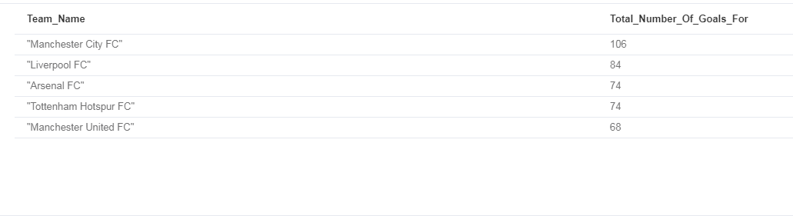
5-Result

//Creates the relationship initially
MATCH (t1:Team)-[x:PLAYED_HOME_IN|PLAYED_AWAY_IN]->(m:Match)<-[y:PLAYED_HOME_IN|PLAYED_AWAY_IN]-(t2:Team)
//taking to account the goals from the opposite relationship
RETURN t2.name as Team_Name, SUM (x.FT) as Goals_Against
ORDER BY Goals_Against DESC
LIMIT 5
Matching the relationship and takes in account the sum of goals from the opposite relationship. The concept of this query is the same with query 5 , with the only difference that in this case the correlation between teams and goals is the opposite.
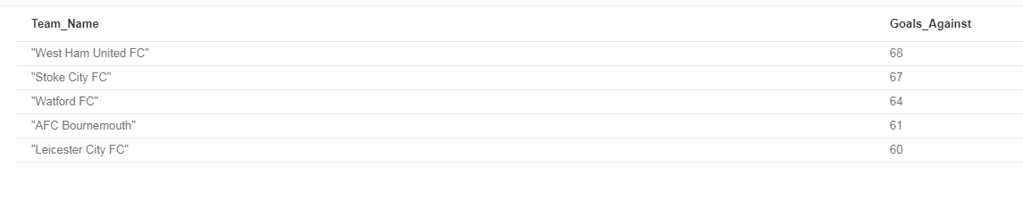
6-Result
//The purpose of this query is to combine two queries
// this can't be done with another way
//initially fetches the first relationship and the nodes as
//finds the relationship with result Draw
//collects the team name and the draw result into a row called rows
//Subsequently matches the second relationship and the node as an away
//finds the relationship with result won
//collects the team name and the won result into a row called rowss
//

//Total points
MATCH (t:Team)-[r:PLAYED_HOME_IN|PLAYED_AWAY_IN]->(:Match)
WHERE r.result = 'DRAW'
WITH collect ({name:t.name, draws:r.result}) as rows
MATCH (t:Team)-[r:PLAYED_HOME_IN|PLAYED_AWAY_IN]->(:Match)
WHERE (r.result = 'WON')
with rows + collect ({name:t.name, wons:r.result}) as rowss
UNWIND rowss as row
with count(row.wons)*3 as Points_For_Wins,count(row.draws) as Points_for_Draws,row.name as Team_Name
RETURN Team_Name, (Points_For_Wins+Points_for_Draws) as Points
ORDER BY Points desc
LIMIT 5
This query is quite complex because it requires a combination of two queries. The basic concept is to calculate how many draws and how many wins a team has to its record. The collect clause “collects” and stores them in to a specific variable (Kharwar,2016). Subsequently the unwind clause creates distinct list and transforms them into individual rows. After fetching the relationships and nodes finds the result draw and stores the name and result in to variable rows. Subsequently executes the second query and perform the same process. It sums the first variable with the second rows and then parses it to a third row. In order to count the points, the frequency of property WON have been multiplied with 3 and returned as a sum of Draws and wins order by descending order limited by the first 5.
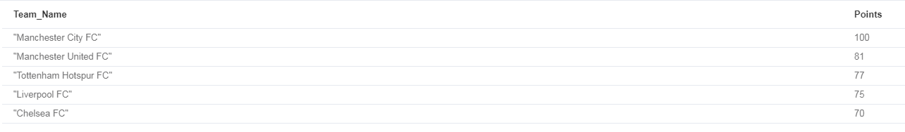
7-Result

MATCH (t:Team)-[r:PLAYED_HOME_IN|PLAYED_AWAY_IN]->(:Match)
WHERE r.half_result = 'DRAW'
WITH collect ({name:t.name, draws:r.half_result}) as rows
MATCH (t:Team)-[r:PLAYED_HOME_IN|PLAYED_AWAY_IN]->(:Match)
WHERE (r.half_result = 'WON')
with rows + collect ({name:t.name, wons:r.result}) as rowss
UNWIND rowss as row
with count(row.wons)*3 as Points_For_Wins,count(row.draws) as Points_for_Draws,row.name as Team_Name
RETURN Team_Name, (Points_For_Wins+Points_for_Draws) as Half_result_Points
ORDER BY Half_result_Points desc
LIMIT 5

The concept of this query is the same with the query 7. In this case the property that is considered is the half_result instead of result.
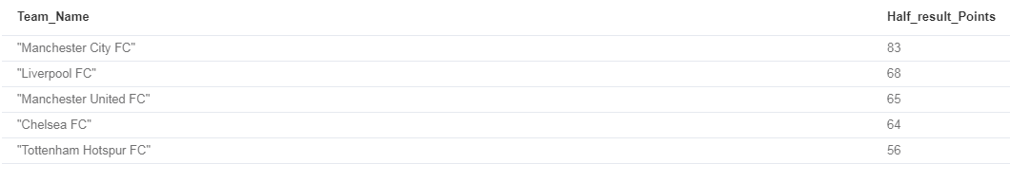
8-Result

MATCH (t:Team)-[x:PLAYED_HOME_IN|PLAYED_AWAY_IN]->(m:Match)
WHERE x.result =~ '.*LOST.*'
RETURN t.name as Team_Name, COUNT (x.result) as Lost_Games
ORDER BY COUNT (x.result) DESC
Initially matches all the relationships and the nodes with labels Match, Team. Filters where the result of the relationship contains the string LOST and returns the frequency number of this variable that each team is correlated.
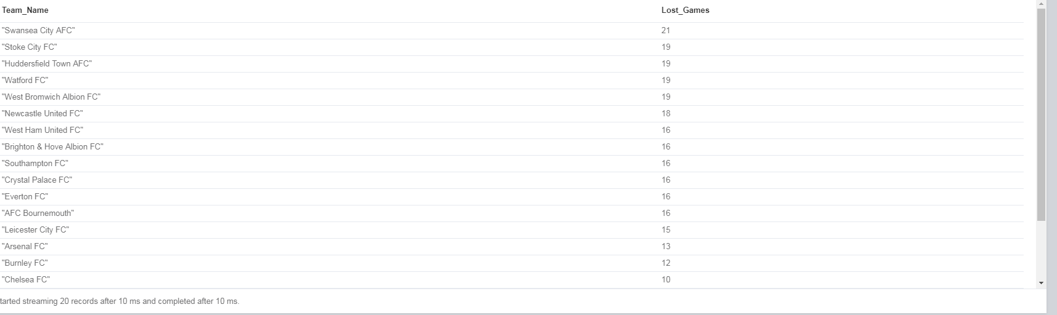
9-Result

